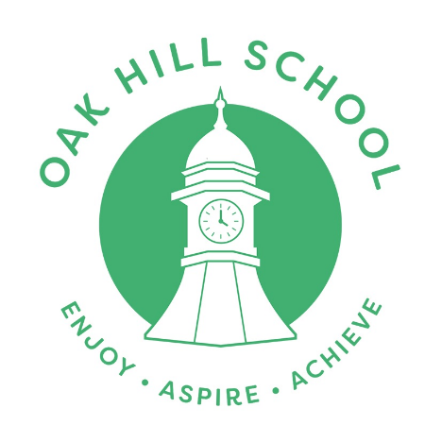
Oak Hill Term Dates 2026 - 2027

Autumn Term 2026

Start - Tuesday 2nd September 2026
End - Friday 18th December 2026 (school finishes at 12pm)

Half Term: Monday 26th October 2026 - Friday 30th October 2026

Progress day: TBC

Spring Term 2027

Start - Tuesday 5th January 2027
End - Thursday 25th March 2027 (School finishes at 12pm)

Progress day – TBC

Half Term: Monday 15th February 2027 - Friday 19th February 2027

Summer Term 2027

Start – Monday 12th April 2027
End – Tuesday 20th July 2027 (School finishes at 12pm)

Progress day: TBC

Half term: Monday 31st May 2027 – Friday 4th June 2027

May Day Bank Holiday – Monday 3rd May 2027

School Closures for Staff Training (subject to change)
Tuesday 24th November 2026 (half day inset from 12pm)
Thursday 4th February 2027 (half day inset from 12pm)
Tuesday 23rd March 2027 (1 day inset)

* Wednesday 21st July 2027 (Extra day holiday due to twilights).
* Thursday 22nd July 2027 (Extra day holiday due to twilights).

This calendar gives a total of 195 days (190 pupil days plus 5 inset days).

