IT Disaster Recovery Plan
Oak Hill

Version 1.1 15 June 2024

1.0 INTRODUCTION

The purpose of this document is to outline the procedures involved in recovering from an Information Technology incident.

An incident can range from complete loss of the school facility (where this plan would feed into and bolster the school’s critical incident plan) to the loss of an individual component (PC, network, software environment, etc.) to the loss of important data (current files, archived files, financial data sources, anything not easily reproduced).
In preparing this plan, it is important to note that the expectation is (in the normal course of events) systems will fail, data will be lost, service delivery will be intermittent, etc. As such, not every incident will be categorised as a ‘disaster’. This is normal practice and any plan should seek to establish mechanisms that will see things restored back to the status quo within defined and acceptable time frames which will vary depending upon the individual components.

Only when restoration will exceed the maximum tolerable outage (MTO) would a disaster normally be declared. The actual time to restore a component from an incident is only one part of the overall MTO. The plan needs to take into account detection time and other management processes prior to invoking the recovery process.
Restoration of individual components will involve some amount of effort and technical knowhow that may and probably will lie external to the existing school staff. Where this is the case, these resources need to understand and commit to this plan, if its objectives are going to be met.

This plan summarises the results of a comprehensive risk analysis conducted for all IT components. It provides general steps that will be taken in event of a disaster to restore IT functions and provides recommendations for ‘hardening’ of the IT infrastructure that may require management approval and additional funding to implement.

2.0 OBJECTIVES

The primary objective of this IT Disaster Recovery Plan is to help ensure continuity of service for Oak Hill School by providing the ability to successfully recover computer services/data in the event of a disaster.

- Specific goals of this plan relative to an emergency include:
- Detailing a general course of action to follow in the event of a disaster,
- Minimising confusion, errors, and expense to the school, and
- Implementing a quick and complete recovery of services.

3.0 KEY SYSTEM COMPONENTS

Listed below is an overview of the school servers. Every server is considered to be critical in the smooth running of the network. The list includes both physical and virtual servers.

3.1 LOCAL SERVERS OVERVIEW

Server Name | IP Address | Physical/Virtual | Description
APB-OH-HOST-01 | 10.14.3.240 | Physical | Hyper V Host
APB-OH-DC-01 | 10.14.3.245 | Virtual | Domain Controller /Files Server
APB-SCDP-01 | 10.14.3.247 | Virtual | SCCM Server
SCHOOLNAS | 10.14.1.27 | Physical | Local backup of servers

3.2 NETWORK COMPONENTS OVERVIEW

Server Name | IP Address | Physical/Virtual | Description
SONICWALL | 10.14.0.1 | Physical | Firewall / Net Filter / Internet Gateway
APB-OH-DC-01 | 10.14.3.245 | Virtual | Domain Controller /Files Server

3.3 CLOUD SERVICES OVERVIEW

Service Name | Address | Description
Schoolpod | Schoolpod.com | School Register
 |  | MIS
Email | Office.com | Microsoft cloud email service
One Drive | Office.com | Cloud based file storage

Backup and recovery of cloud services is the responsibility of the service provider. Failure of the school network, power loss, loss of internet will make these services unavailable in school. In the event of the loss of the school, these services will remain immediately available to any new premises with internet or for staff working remotely.

3.4 FILE STORAGE OVERVIEW

Service Name | Address | Description
Local Storage | APB-OH-DC-01 | General share
Cloud Storage | One Drive / Sharepoint / Teams | Admin / Finance

4.0 UNDERSTANDING AND DEFINING DISRUPTION OF SERVICE

Objective | Actions/Considerations
Confirm the nature of the disruption | What has happened?  When did it occur?  Which systems and/or services are affected?  How potentially serious is it?  What is the estimated duration of the problem?  Who else has been informed (staff/ suppliers / customers)?
Decide whether to invoke Network Infrastructure Recovery plan (See point 7.0/7.1) | The decision will be based upon the information provided consideration should be given to:  How long systems will be unavailable?  Whether the systems affected are required to support the school priorities?  Whether the area is currently responding to an external incident?  Inform staff that the Business Continuity Plan is being invoked or put staff on standby or invoke agreed manual systems to ensure that the service can continue to operate.  If the decision is made not to invoke the plan, continue to monitor the situation until such time as normal service is resumed.

5.0 KEY CONTACTS

Name | Job Title / Service | Company | Contact
Mike Goodsir | IT Consultant | Turn IT On!  Ltd | M: 07943 333612  mike.goodsir@turniton.co.uk
Turn IT On Helpdesk | Helpdesk Service | Turn IT On! Ltd | T: 01844 318550  support@turniton.co.uk
Nicola Baker | Business Manager | Oak HIll
Kevin Grant | Head of School | Oak Hill

6.0 SCHOOL PRIORITIES

Priority | Function
1 | Access to the school’s Management Information System
2 | Access to the Internet for Admin
3 | Registration System
4 | Email for Admin/Teaching Staff
5 | Focal Point/Dimensions/HCSS/Access
6 | Access to stored data, i.e. Admin drive, Staff drive
7 | Access to the Internet Curriculum teaching staff
8 | Other network resources i.e. printing

7.0 PROCEDURES
7.1 Network Infrastructure Recovery

The following procedure should be carried out to initiate Network Infrastructure Recovery:
In the event of an identified network infrastructure failure, the school should call the Turn IT On Helpdesk as soon as possible.

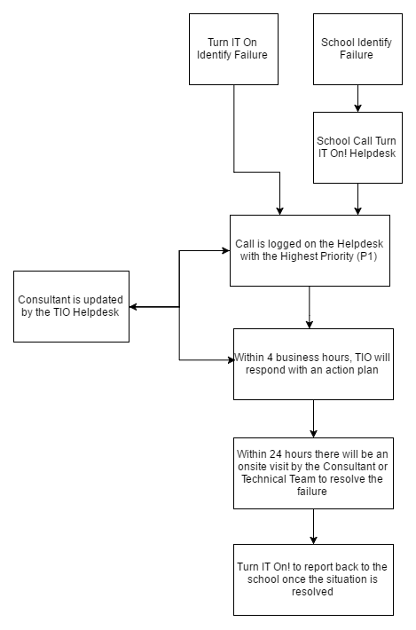

7.2 POWER LOSS

7.3 SERVER FAILURE

the event of failure of the server it is crucial to immediately place a call with the Turn IT On helpdesk. TIO treat any server failure as highest priority (P1) and will put all their resources behind it.

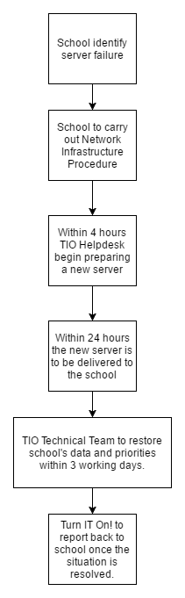
Exports of the virtual servers are held on a USB drive stored in the safe in the main office. This will facilitate the option of delivering a virtual host to site and then importing the backup copies of the virtual server.

7.4 LOSS OF SCHOOL PREMISES OR THEFT OF PROPERTY

In the event of total server failure or theft: If the server suffers a total failure which is not recoverable (e.g. fire or other natural disaster), has been stolen or any other event which has caused a total failure of the server. New physical server hardware will need to be ordered by the school, meanwhile TIO will endeavour to build and provide loan server s. Once installed recovery of service is accomplished by importing the backup virtual machine and / or from Windows Server Backups.

8.0 RECOVERY PROCEDURES

8.1 DATA RECOVERY

Back Up Systems Used & Recommended Procedures

Local Server – APB-OH-DC-01

The local server is critical to the operation of the local network and provides the following services.
DHCP – required for local devices to obtain a network address.
DNS – name translation services.
Domain Controller – required to provide services for users to logon to computers at Oak Hill
The following file shares are provided by the server.
At the time of writing some data such as student files are held on the server, with the intention of moving to assignments in Teams as a method of storing student files in the cloud. Finance and administration data is held in the cloud accessible via Teams and OneDrive.
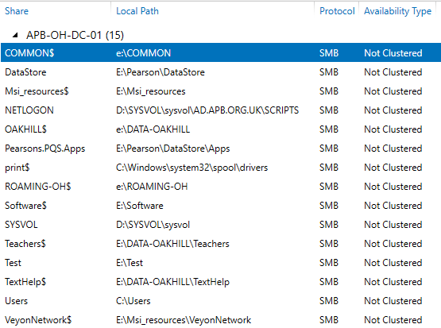

Backups – 1. Windows Server Backup
The local server APB-OH-DC-01 is backed up to an external network device SCHOOLNAS using Windows Server Backup. The backups are a nightly full server backup allowing recovery of single files to a full server restore including system state.

SCHOOLNAS is physically located in the main communications cabinet.

Backups- 3. Virtual machine export.
A periodic export of the virtual machines is held on a USB drive.

One drive is stored in the safe located in a strong room.
One drive is taken off site whilst the third is online backing up.

The purpose of the virtual machine export is to provide an offline backup that cannot be affected by an encryption attack.

Cloud Services – OneDrive / Teams

The main location for storing files now utilises Microsoft cloud services, storing files within Sharepoint, accessing via OneDrive and Teams.

Microsoft services provide the ability to recover deleted files for up to 30 days after deletion. In the event of an encryption attack files can often be restored using the version control built into the service.

A further level of backup and recovery of files and emails is provided by Barracuda cloud to cloud backup. This is backing up the files stored by Microsoft in Sharepoint and staff emails hosted by Microsoft.

