

School Dog Policy

Date Written / Reviewed: September 2023
Next Review: September 2025

Ratified By Trustees On:28.06.24

OAK HILL SCHOOL MISSION STATEMENT

Oak Hill School is a welcoming and supportive environment where children can thrive socially, creatively, and academically. Our commitment to understanding each student's unique needs drives us to provide personalised pastoral support and effective behaviour guidance, ensuring high-quality learning experiences. Collaborating closely with our partners, we deliver a diverse and engaging curriculum that caters to the individual needs of our learners. Our guiding values: Friendship, Equality, Respect, Resilience and Excellence—shape the foundation of our school ethos. Recognizing that some of our students have faced challenging experiences, both at school and at home, we aspire to make Oak Hill School a place where they can rediscover the joy of learning. Through our school motto: Enjoy, Aspire and Achieve; our goal is to inspire them to dream big, fostering aspirations to become the individuals they envision, ultimately evolving into the best versions of themselves. The dedicated staff at Oak School provide unwavering support, guiding them towards the realisation of their ambitions.

Purpose

Dogs teach children responsibility. Having to remember to feed, provide water and show support for a dog can give children a sense of importance and satisfaction that they can’t get from school or other chores. The relationship that develops can be life- changing for a child and a great support system as they themselves continue to grow and develop.

Dogs teach children patience. Dogs do not always do as they are told first time!

Dogs teach children compassion. Just like humans, dogs feel emotion and pain. They are prone to injuries and the infirmities of age during their relatively short lives.

Dogs teach children about socialisation. Like most of us, dogs are social animals who enjoy and need attention and affection. By learning how to interact with a dog, children can learn how to better socialise with other children. If they can learn the social cues of a dog, then interacting with humans who can talk will be a walk in the park (pun intended).

Dogs are fun. Last, but certainly not least, dogs are a lot of fun. They greet you with a wagging tail every day and can cheer you up even on your worst day.

- Many people have studied dogs in attempts to decipher their behaviour, and the theories abound. However, you just have to witness the interactions between dogs and children to realise the potential for greatness. Dogs can sense when children with epilepsy, are about to have a seizure, they can sense when a diabetic child’s sugar is low, and they can help children with severe physical disabilities find happiness in life.

- We also believe she will improve the children’s abilities within the school’s core values and further improve our attendance levels and attainment levels.

Guidelines for Interaction with any dogs visiting Oak Hill

- Under no circumstances will children have close interaction with the school dog unless they are happy to do so. All parents are aware that dogs will be spending time in school. Parents / carers can inform the school that they do not wish for their child to interact with the dog.

- At all times interaction with the dogs must be controlled and safe for adults, children and the dogs themselves. If the following guidelines are not followed interaction with the dogs will be cancelled.

- At all times of interaction there must be an authorised adult who takes the leading role when interacting with the dogs. If children, or visiting adults, do not abide by the guidance given by the authorised adult the interaction will be cancelled.

- The following guidelines must be followed when interacting with the dogs. These guidelines apply to all adults and children.

- There must be an authorised adult present during all interaction
- Always approach the dog calmly (voice and movement)
- Always approach the dog slowly
- Never run up to the dog
- To start interaction the back of a hand will be offered for the dog to sniff.
- Keep noise levels low during interaction with the dog.
- All interaction must remain calm with the authorised adult staying in control at all times
- Only the authorised adult can move any of the dog’s resources, including food and treats.
- Visiting children and adults can only handle equipment or give treats if the authorising adult gives permission.

- There must not be any interaction with the dog whilst they are eating.
- After all interaction with the dog hands must be washed with soap and water/ hand gel
- When interacting with the dog all children must remain on their feet and not kneel or lay down unless guided to by the authorised adult
- If the dog is with an authorised adult they do not need to be on a lead when in school.

- As the dog becomes more established there will be times when interaction will take place outside. On these occasions the following guidelines apply in addition to the guidelines outlined above

- No children will ever be asked to pick up faeces
- If walking the school dog, an authorised adult must be present at all times. Children may hold the dog’s lead if they are confident to do so. The authorised adult remains in charge of the situation at all times and will take back the dog’s lead if necessary.

- There is also a detailed and individual risk assessment completed biannually for each dog who visits Oak Hill School.
- Each dog’s owner will be responsible for any mess and or damage caused and any associated costs.

Introduction to Moira

- ‘Moira’ has lived with Darren Prendergast and his family since she was 8 weeks old. She is a service dog and very much a family dog. She has the right temperament to work with a wide range of children and adults within the school environment. Moira is a very caring and well-behaved dog.

- Moira’s Mother is a cocker spaniel, and her Father is a toy poodle. This makes Moira a cockapoo.

- Moira regularly visits the vet for check-ups. Whilst she is there, they administer worm and flea treatments as well as make adjustments to her food intake to ensure she remains a healthy weight.

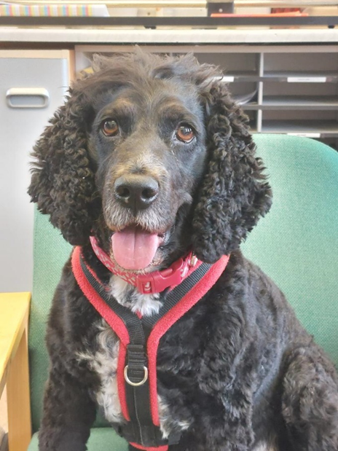

Introduction to Chester

- ‘Chester’ has lived with Wendy Hartley and her family since he was 8 weeks old and he is still a puppy. He has started the Kennel Club Good Citizen Dog Training Scheme and is very much a family dog. He has the right temperament to work with a wide range of children and adults within the school environment. Although Chester is still a puppy he has learned very quickly how to behave and has mastered his training quickly.

- Chester is a Kennel Club registered Golden Retriever with a healthy and fully documented family history.

- Chester regularly visits the vet for vaccinations and check-ups. He also receives regular worm and flea treatments.



