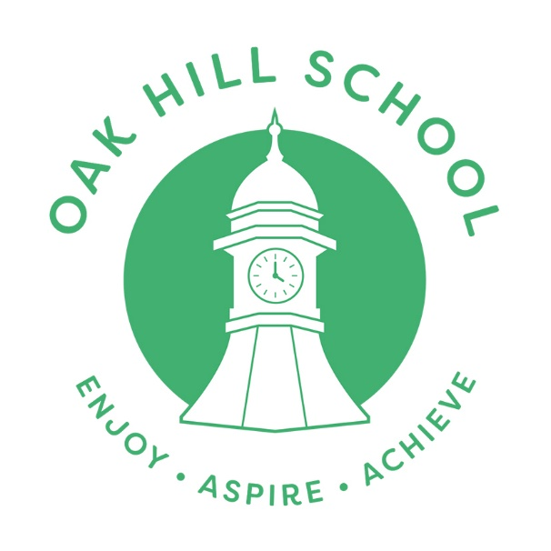

Careers Policy & Provider Access Statement

Date Written / Reviewed: May 2024
Next Review: May 2026

Ratified By Trustees On: 28.06.24

OAK HILL SCHOOL MISSION STATEMENT:

Oak Hill School is a welcoming and supportive environment where children can thrive socially, creatively, and academically. Our commitment to understanding each student's unique needs drives us to provide personalised pastoral support and effective behaviour guidance, ensuring high-quality learning experiences. Collaborating closely with our partners, we deliver a diverse and engaging curriculum that caters to the individual needs of our learners. Our guiding values: Friendship, Equality, Respect, Resilience and Excellence—shape the foundation of our school ethos. Recognizing that some of our students have faced challenging experiences, both at school and at home, we aspire to make Oak Hill School a place where they can rediscover the joy of learning. Through our school motto: Enjoy, Aspire and Achieve; our goal is to inspire them to dream big, fostering aspirations to become the individuals they envision, ultimately evolving into the best versions of themselves. The dedicated staff at Oak School provide unwavering support, guiding them towards the realisation of their ambitions.

Introduction
- Oak Hill School provides a broad and balanced curriculum at levels appropriate to the developmental understanding of our students. Our curriculum approach reflects our respect for each student as an individual, aiming to develop knowledge, understanding, and self-reliance and coping skills in a supportive environment that minimises distress.

- Our curriculum aims to reflect our intent to provide a relevant and engaging careers curriculum based around achieving the Gatsby Benchmarks which meets the differing needs and requirements of our students. This is developed throughout a student’s time at the school and is always supportive of their abilities, strengths, and skills.

- Careers aspirations are recorded as part of the Education Health and Care Plans (EHCP) process from Year 9 onwards. In collaboration with parents/carers and students, aspirational and personalised long term and short-term outcomes are set under and ways in which we can support the young person achieve these are agreed. This includes access to a qualified Independent Careers Adviser who provides guidance on meeting their individual needs. From Year 10 a Careers Action Plan is created and updated regularly throughout the transition process to Post 16.

- This policy summarises the statutory guidance and recommendations and sets out the school’s arrangements for managing the access of providers to students at the school for the purposes of giving them information about the provider’s education or training offer. This complies with the school’s legal obligations under Section 42B of the Education Act 1997 as well as the Education Act 2011 which secures additional access to face-to-face external specialist guidance. It also takes account of the New Legal Careers Guidance – Access for Education and Training 2023
- As a SEN Special Academy, Oak Hill School will aim to work in partnership with other education and training providers to tailor a personalised service to students at the school that is inclusive and takes account of their individual level of development, strengths, and interests incorporating Gatsby Careers Guidance and benchmarks, as stipulated by D of E.

- The school caters for pupils who have Social, Emotional and Mental Health difficulties. Many pupils have additional diagnosis such as for ADHD, Autism Spectrum Disorder., Learning needs and Cognitive difficulties.

- All pupils have an Education Health Care plan (EHCP)

Statutory Requirements & Recommendations
- Careers education provision at Oak Hill School is in line with the statutory guidance developed by the Department for Education, which refers to Section 42A and 45A of the Education Act 1997. This states that all schools should provide independent careers guidance from Years 8 -11 and that this guidance should:
- Be independent and impartial.
- Include comprehensive information on a range of pathways covering Technical Education. This includes T Levels, Apprenticeships, Traineeships and Supported Internships
- Be adapted to the needs of the student.
- Support students in planning and managing their own futures by preparing them for independent life, through well round experiences appropriate to the individual
- To promote equality, diversity, and social mobility
- Offer 2 encounters with the range of technical education opportunities (as above) in Years 8/9, 10/11, as and when appropriate.
- In addition, the school is compliant with the career’s guidance set out by government for delivery from 5 January 2018: ‘Careers Guidance and Inspiration for young people in schools’ and the new ‘Legal Duty for Schools and Academies: access to providers of technical education and apprenticeships 2023. This states that all schools must include comprehensive information on a range of pathways covering technical education. This includes T Levels, HTQ, Apprenticeships, Traineeships and Supported Internships. This can be supported by education and training providers being given the opportunity to talk to students about the range of Post 16 Options both internally and externally.
- Careers and preparing for life after Oak Hill School are a fundamental aspect of our curriculum:
- All students have a formal opportunity to attend all or part of their Education, Health, and Care Plan annual review meeting. From Year 9 onwards, a discussion is held regarding their short and long-term Preparing for Adulthood outcomes as well as their aspirations for the future. These are discussed and agreed with parents / carers and other professionals. They also include the school’s Independent Careers Adviser in Years 10 and 11.

- Prior to their Annual Review Meeting students are supported by the SENCO to complete their Initial Transition Plan which includes their interests and aspirations for the future. That same document also looks at strengths and areas of need under the four categories of Preparing for Adulthood.

- All students from Year 8 have access to advice and guidance from our Independent Careers Adviser and Destinations lead. Students and their parent/carers have access, to group talks on what options are available and what they include as well as bespoke careers advice and guidance hosted at Oak Hill School on Progress Days (3 times a year) as well as visits, to providers appropriate to the needs of the individual through internal or external means. Visitors into school and offsite visits support students in developing their understanding of a range of different post 16 pathways

Key Stage 3
- Students begin to think about different careers by looking at people who help us both at school and in the wider community.
- This will include the opportunity where appropriate for 2 encounters with Post 16 Providers within school time.
- Have access to careers resources to help them explore and understand what careers and options are open to them.
- Students will be invited to take part in various careers information activities across the school year

Key Stage 4 and Post 16
- Students in Year 11 who are due to leave at the end of the academic year are invited with their parents and carers to meet with the Independent Careers Adviser to discuss possible options available when they leave school. This will ensure they have the knowledge of Post 16 options available. They are also offered support and guidance with the application process:

- An annual event in December on Student Progress Day gives students and their families the opportunity to attend a presentation given by the school destinations lead and the Independent Careers Adviser as well as meeting guest speakers from different pathways to discuss future educational opportunities beyond Oak Hill School.

- Students and their parent /carers can attend the Careers and Guidance Coffee Morning where they will be given the opportunity to speak to the school’s Independent Careers Adviser together with the Oak Hill School Careers lead to gain information about future choices.

- Some students in Year 11 and/or Year 10 undertake Work Experience and work-based placements and opportunities. This will be supported by our Careers Lead and Careers Adviser as and when appropriate.

- Through the options on offer in KS4 students will have opportunities to gain knowledge of work-related learning to further develop understanding of job roles and responsibilities, personal skills, qualities and interests.

- The school provides appropriate labour market information which can be visualised on the Careers Calendar also available on the Oak Hill School Website.

- The school provide previous Destination outcomes for the past three years on the Oak Hill website.

- To increase knowledge and aspirations the school provides labour market information through a range of college visits, open days, vocational visits and guest speakers where appropriate

Provider Access Statement
Student entitlement
- All students in years 8-11 are entitled to the following in line with Gatsby Benchmarks.
- A Stable Careers Programme Every school and college should have an embedded programme of Careers Education and Guidance that is known and understood by pupils, teachers, governors, and employers.
- Learning from Career & Labour Market Information
- Every pupil, and their parent/carer, should have access to good quality information about future study options and labour market opportunities. They will need the support of an informed adviser to make best use of available information.
- Addressing the Needs of Each Pupil
- Pupils have different transition and career guidance needs at different stages. Opportunities for advice and support need to be tailored to the needs of each pupil. A school’s careers programme should embed equality and diversity considerations throughout.
- Linking Curriculum Learning to Careers
- All teachers should link curriculum learning with careers. STEM teachers should highlight the relevance of STEM subjects for a wide range of career paths.
- Encounters with Employers & Employees
- Every pupil should have multiple opportunities to learn about work, employment and the skills that are valued in the workplace. This can be achieved through a range of enrichment activities including visiting speakers, mentoring and enterprise schemes.
- Experiences of Workplaces
- Every pupil should have first-hand experience of the workplace through work visits, work shadowing and/or work experience to help their exploration of career opportunities and expand their networks.
- Encounters with Further and Higher Education
- All pupils should understand the full range of learning opportunities that are available to them. This includes both academic and vocational routes and learning in schools, colleges, universities and in the workplace.
- Personal Guidance

- Every pupil should have opportunities for guidance interviews with a careers adviser who should be external and trained to an appropriate level. This should be available whenever significant study or careers choices are being made. This should be expected for all pupils but timed to meet their individual needs.

- At Oak Hill School, entitlement for the above will be achieved through a modified and personalised careers education programme, which is integrated into our broader life skills curriculum to support the school mission statement of “Learning for Life”.

- The annual review of each student’s Education, Health and Care Plan will provide regular opportunities for discussion of future education and training options.

- The school will hold an annual event for local and regional education and training providers to meet students and their families.

Premises & Facilities
- The school will make the main hall, classrooms, or small meeting rooms available for discussions between providers, students, and their families as appropriate to the activity. The school may also make available specialist equipment to support provider presentations on the basis that this will have been discussed and agreed in advance of the visit.

- Providers are welcome to leave copies of their prospectus or other relevant course literature at the school that may be used as part of our careers programme.

Management of Provider Access Requests

- The school will also make ad-hoc opportunities for providers to meet with small groups or individual students and their families as appropriate.

- A provider wishing to request access should contact Sharon Glover – Independent Careers Adviser 07864317643, Cath Thorley, Careers and Destinations Lead .Telephone: 0208 361 4639

