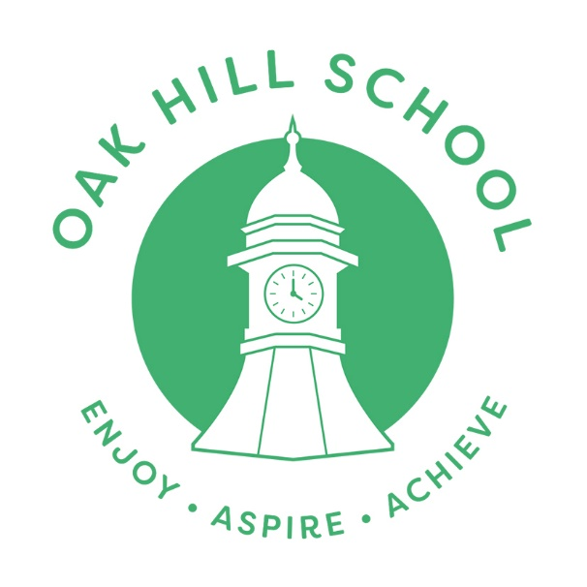

Statement of British Values

Date Written / Reviewed on: March 2024
Next Review: March 2026

Ratified By Trustees On: 22.02.24

OAK HILL SCHOOL MISSION STATEMENT

Oak Hill School is a welcoming and supportive environment where children can thrive socially, creatively, and academically. Our commitment to understanding each student's unique needs drives us to provide personalised pastoral support and effective behaviour guidance, ensuring high-quality learning experiences. Collaborating closely with our partners, we deliver a diverse and engaging curriculum that caters to the individual needs of our learners. Our guiding values: Friendship, Equality, Respect, Resilience and Excellence—shape the foundation of our school ethos. Recognizing that some of our students have faced challenging experiences, both at school and at home, we aspire to make Oak Hill School a place where they can rediscover the joy of learning. Through our school motto: Enjoy, Aspire and Achieve; our goal is to inspire them to dream big, fostering aspirations to become the individuals they envision, ultimately evolving into the best versions of themselves. The dedicated staff at Oak School provide unwavering support, guiding them towards the realisation of their ambitions

Statement of British Values

The DfE have recently reinforced the need “to create and enforce a clear and rigorous expectation on all schools to promote the fundamental British values of democracy, the rule of law, individual liberty and mutual respect and tolerance of those with different faiths and beliefs.”
The Government set out its definition of British values in the 2011 Prevent Strategy, and these values were then reiterated by then Prime Minister David Cameron in 2014. At Oak Hill School these values are taught in the following ways:

Democracy:
One of the fundamental values at Oak Hill School is the right of all members of the community to be heard and the responsibility of others to allow this to happen. This is taught and reinforced through all lessons, teaching and modelling of young people, how to make their needs and wishes heard in a way that society and school life finds acceptable. This is done throughout every lesson and taught explicitly through Citizenship and PSHE, but also through experiences of the wider curriculum including enrichment activities. Students have the opportunity to have their voices heard through daily tutorials and through the student council. Our school behaviour policy involves rewards which further seek to affirm student voice.

The Rule of Law:
The importance of Laws or rules, whether they are those that govern the classroom, the school, or the country, are consistently reinforced throughout regular school days. During induction and throughout their time in the school, students are taught the value and reasons behind the schools rules, what they mean and how they look when people are following them. There is part of the PSHE curriculum discussion and debate about the rules that govern and protect us, the responsibilities that this involves and the consequences when laws and rules are broken. Visits from a range of organisations form part of our regular curriculum and often part of individual packages needed to support young people. The fundamental and principal right to feel and be safe is paramount in all aspects of the school.

Individual Liberty:
Within school, young people are actively encouraged to make positive choices, knowing that they are in a safe and supportive environment. As a school we educate and provide boundaries for students to make choices safely, through the provision of a safe environment, staff with whom they have a positive and supportive relationship

and boundaries that are secure. Students are encouraged to know, understand and exercise their rights and personal freedoms and are advised as to how to exercise these safely. In addition, students are encouraged to consider their responsibility in making their choices and how these will impact on themselves and others in the immediate and long term future. This may be in PSHE, target setting or at any point within the school day.

Mutual Respect:
Part of our aim for every student is to develop a healthy respect for themselves, to build self-esteem, self-worth and confidence as a learner. This informs our core purpose to ensure that every student does better than they thought they would. It is threaded through learning and teaching, and safeguarding policies. It is part of daily discussions about personal behaviour targets, weekly targets setting and taught directly. It is modelled daily by all staff and is an expectation of the whole community.

Tolerance of Difference:
This is achieved through deepening the understanding of students’ own needs and those of others. It is impressed upon them that they belong; to the school community and their world community. Much of the work at Oak Hill School is about overcoming anxiety about differences but equally celebrating and embracing difference though celebration of achievements, developing understanding of diversity through working with visitors from a range of cultures and belief systems. We have a very diverse staff in terms of gender, ethnicity and age and believe that this visually exemplifies to students the reality of people of different backgrounds uniting for a common good. Staff tackle issues around prejudice, injustice and bullying on a 1-1 and whole school level with rigour an are skilful in the use of restorative justice strategies to support ‘moving on’ after an incident. Members of different faiths or religions are encouraged to share their knowledge to enhance learning within classes and the school.

